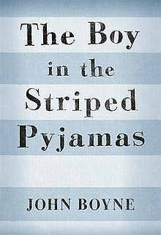
The Boy in the Striped Pyjamas
- Reflections on the novel
This will be your final exercise connected to the book The boy in the striped pyjamas. Answer the questions below as thorough as you can. Your text needs to be at least 1-1,5 handwritten pages.

Theme 1 – the ending
- What happens in the end?

- Were you surprised by the ending? Why? Why not?

- How have characters changed from the beginning to the end of the novel?

- Is there a hero in this story? If so, what makes him/her a hero?

- Is there a villain in this story? Explain your answer.

Theme 2 – an innocent perspective (=ett oskuldsfullt perspektiv)
- Neither Bruno nor Shmuel really know what´s going on at the concentration camp. Why is that? And what allows them to keep their innocence?

- Does Bruno change during the story, does he get more aware of what´s going on? Explain your thoughts and give examples.

- Why do you think the author chose to tell the story from Bruno´s, a child´s, perspective?

Theme 3 – the essence of friendship (=betydelsen av vänskap)
- Why do you think Bruno and Shmuel become friends and stay friends?

- How does the friendship that Bruno has in Berlin at the beginning compare with his friendship with Shmuel?

- Does the friendship between Bruno and Shmuel change in the story? How?

- The barbed wire fence physically separates Bruno and Shmuel – what other types of separation does the fence represent in this story?

