TedTalks - a project about holding speeches
This is a work where you practice the skill of speaking in front of an audience.
During 8 weeks you will prepare, write and hold a speech for 1,5-3 minutes. You can talk about anything you like but the purpose of your speech is that it should move the listeners. The work is divided into four different parts.
The work is divided into four different parts
Part 1: We watch, analyze and discuss the content of different speeches on Ted.com and talasomted on youtube.
We talk about different subjects that can be suitable. You reflect on the subjects and choose a subject for your speech. When you have chosen a subject, do a mindmap.
- to choose a subject
-knowledgeskills
Part 2: In this part you write your speech using your mindmap and a writinginstruction that is divided into 4 pieces (of a puzzle). Each part needs to be continuously presented to your workgroup.
- introduction (first piece of the puzzle)
- your story (second piece of the puzzle) -pathos (third piece of the puzzle))
- punch line (fourth piece of the puzzle)
Part 3: In this part you add some pictures to your presentation and practice your speech over and over again for as many people as possible.
- pictures and practice
Part 4: The speech, preparations and holding your speech -checklist
Part 1

TedTalks – To choose a subject
Now it is time to start working with your speech. Before you start writing a good speech you need to be clear on one thing and that is what you're going to talk about. You can talk about anything you like but it has to be something that you have experienced yourself. Your feelings, your ideas and your heart.
Subjects to talk about could be the following:
- a place that I have visited
- a travel that I have made
- a person that I have met or know that has made a difference to my life
-an incident that most people haven't experienced
-something that I have made by myself, like a painting, a photograph I've taken or a text that I have written
When you have decided what to write about, make a mindmap to ensure that you have enough to say about your subject to make a speech. Also make sure that you feel comfortable taking about your subject.
Now that you have decided what to talk about it is time to write your subject.
Good luck!

Part 1
TedTalks – Skills that you practice

Förmågan att kommunicera muntligt (tala och samtala)
Förmågan att kommunicera i tal och att anpassa språket efter syfte, mottagare och sammanhang, samt urskilja språkliga strukturer och följa språkliga normer
- träna uttal, intonation, grammatik, satsbyggnad och ord
- anpassa talet efter mottagaren och använda strategier för att hålla igång det genom att berika som intonation, utryck, grammatik och uttal
- bearbeta framställningarna för att variera, tydliggöra, precisera och anpassa efter syfte

Förmågan att kommunicera i skrift
Förmågan att kommunicera i skrift och att anpassa språket efter syfte, mottagare och sammanhang, samt urskilja språkliga strukturer och följa språkliga normer
- kunna bearbeta och tillämpa skrivprocessen som en strategi vid skrivande, men även använda ordlistor
- kunna skriva i olika genrer som berättelser, beskrivningar, argumenterande texter och instruktioner och göra det tydligt
- kunna omformulera sig då språket inte räcker till
- kunna förtydliga sig och berika genom att använda fasta utryck, grammatik och satsbyggnad

Part 2
TedTalks - The beginning
This is the first part of your speech, the first part of the puzzle. It is really important that you introduce yourself to the audience.
*Greet the audience. Choose a greeting and tell the audience your name.
*Take a short break and look at the audience. Choose a few fellow students and look them in the eye.
*Choose a Beginning and say it here.
What is a Beginning?
A Beginning is something that makes the audience interested in your speech and curious how your speech will end. It can be built like this
1. Ask a question to the audience like Do you know what it feels like.......?
2. ...to ( describe a certain place)
3. ....to (add a feeling)
4. If you like say I do!
This part should not be longer than 60 seconds. Don 't reveal the coresubject of your speech yet. You want the listener to understand what you’ll talk about but still wonder how your story will end. Write down your introduction and read it to yourself, your groupmembers and family.
You can practice and rewrite as much as you like!

Part 2

TedTalks – your story

This is the second part of the puzzle. You are now going to write your story in three stages to make the listener understand more about your subject. You will either write about three things, situations, or places and describe it so well that they almost feel what you feel.
The first stage: The first time………………………. Finish off by looking at the audience.
The second stage: Another time……………………….Look at the audience
Third stage: The day after ………………………………….
Finish this part with a cliffhanger……. Look at the audience
You don't have to use the same words as I have in the instruction above. The important thing is for you to give three examples so the listener understands your feelings.
If you write about a fantastic place then give three examples why this place is so fantastic. If you write about difficulties being a teenager, then give three examples of that e.g. looks, friendship, future (pressure) and explain.

Practice your speech by reading it to your group members. Ask for feedback on your speaking and writing.

Part 2
TedTalks – Pathos
Now it is time to start working with the third part of the puzzle. Begin by reading your beginning “Do you know how it feels….”, the sentences that you wrote in the first piece of the puzzle (A beginning).
Read it exactly the same way as you wrote it. Now you are going to add feelings in three stages. This is the part where you will appeal to the audience’s emotions.
- On the inside: Inside of me it feels……
- Meeting the world: Describe how it feel when you meet someone else.
When I see you /mum/dad/Lisa/grandma/ ….I feel
- On the outside: How do you think you come across? Do you look happy, sad, afraid
When I meet you I look……..

Pathos
It is a Greek word and means appeal to emotions. It is also a speaking strategy used to convince the listener in three stages.

Ask a groupmember to listen to you when you present the third part of the puzzle. Ask for feedback/feedforward on speaking and writing.

Part 2
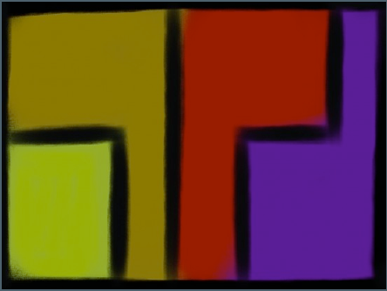
TedTalks – Punchline
This is the final part of the puzzle, piece number four, and you are now going to finish your speech.

Nu är det dags att avsluta. Du vill säga något som får de som lyssnar att minnas talet
– dessutom vill du säga det väldigt kort. Helst ska det vara snyggt också. Den sista
meningen du säger kallas för din ”Punch Line”. Tänk dig att det ska vara som en smäll
på truten, en elchock eller ett skott i mål från halva planen. Slutklämmen, helt enkelt.
Efter slutklämmen säger du tack, väntar in applåder och går av scen.
Det finns flera olika strategier för att skriva en punch line. Här kommer några:
Strategi – Svaret på frågan
För dig som undrar hur det känns… (svara på frågan från pusselbit 1)
Om du känner som jag… (svara på frågan från pusselbit 1)
Du som har varit i samma situation vet att… (svara på frågan från pusselbit 1)
Strategi – Citatet
Avsluta med ett citat från en känd person som passar till det du vill säga.
Du kan citera vem du vill; mamma, pappa, författare, kändis… tala bara om
vem du citerar.
Det finns massor med kloka citat på klokacitat.se eller på ordsprak.se
Säg ungefär ”jag vill avsluta med att citera” eller ”Eller som …… sa:”.
Strategi – Jag är…
#talasomTED, 2013. 10
Säg ditt namn och…
…vad du är. ”Jag är en…”.
Strategi – Inspirationen
Du vill nå de som beundrar dig eller vill vara/göra som du.
Uppmana andra att fortsätta köra, kämpa, våga eller tänka.
Säg åt dem att inte vänta…, inte tveka…, inte tjafsa…, inte strunta i…
Om det passar kan du lägga till: Det är så jag rullar, hejja mig, heja dig, så gör jag,
high 5 eller liknande ganska roliga avslut. Det passar inte att vara rolig i alla tal. Tänk
över noga om det passar för dig.
Läs upp och öva så mycket du bara kan. Du måste bli supersäker på ditt tal. Alla ni
som lyssnar, nu kör vi Fjärilsstilen.

PART 3
#talasomTED - Now practice!

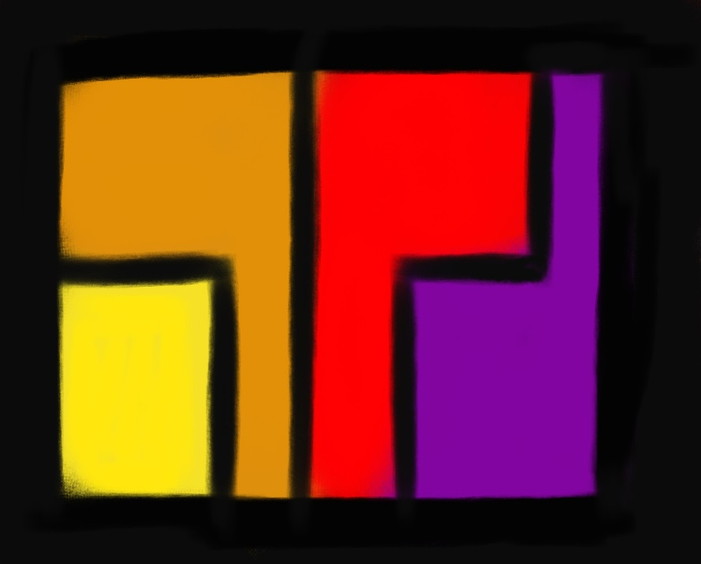

Now your final speech is as a Christmas tree, a really nice Christmas tree. Some of you have left the tree outside the house, some have taken it in, and some of you have begun to decorate it. If your speech is a Christmas tree then here are different things you can do to ensure that Christmas decorations in NK looks like Skrotnisses farm. Select as many of these as you can:

PRACTICE - Practice your speech so that you become ridiculous sure of it. Ridiculous! Secure!
• Read your speech for more and more difficult audience. Start with a friend, then a
teacher, a teacher you do not know, then the scariest student in grade 9, then a foreign
person at the bus stop, then .... Yes, you got it ?!
• Film yourself and watch. Please look with a friend. All your friends need to practice. Repeat again. and again.
• Keep your speech in a way that may disturb you. With music in the ears, lay on your bed, stand on one leg…. Dream it!

Rhetorical figures - rhetorical figures are as professionals (called rhetorician)
use to make speech more professional, give more pathos and become more catching to listen to.
Insert one or more of your speech.

• Three of a Kind - list of three things. There's a reason that there are in fairy tales.
It sounds great!
• Alliteration - words in a short message begins with the same letter or syllable: “She sells sea-shells down by the sea-shore” or “Peter Piper Picked a Peck of Pickled Peppers”
• Antithesis - contrast: black and white, rich-poor, high and low. The bright street towards the
night black sky.
• Rhetorical questions - (instead of making a claim down to a question of
a given response: "Would you be happier?")
• anaphora (before) or Epistrophe (after) - Start or end sentences with the same expression.
Think "I have a dream ..."
• Liknelse(The parable )- Instead of just adjectives / adverbs, you can say "my heart ached as
an evil tooth-mitt hjärta värkte som en ond tand” "or" I stared like a scared cat- jag stirrade som en skrämd katt” "

PRESENTATION - Make a Stylish Picture to have behind you.
• Be careful not to have too much text. No explosions or something which takes
the focus away from you.
• Nice photos.
• Take care so you do not have to stand and change the image every second.

Support words - Make support words so you don´t have to read from your text.

• You can write them down on cards that you can drop on the floor as they are
finished.
• You can add them and have them rolling on an iPad.
• Practice a lot with your key words/supportwords.

Part 4
#talasomTED – The Presentation
Now it's time for the finale!
You must present your speech to an audience !!
Checklist
- Your text.
Make sure you have the latest version of your text.

- Your speaker support.
Make sure you have your text in the hand (paper / iPad).

- Your personal "remembering"
Remember the advice you have got on the road. What three things should you consider?

- Your time and place.
Where will you present your speech and when?
Good luck wishes from Marianne and Camilla!
You are already on your way to a #hejamig!

